Name: Hayden Roche

Student ID: 99245527

1)

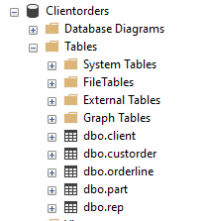

2)

SELECT [firstname], [lastname], [city]

FROM [dbo].[client]

WHERE [city] = 'Dunedin';

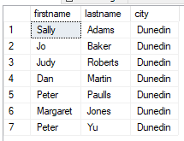

3)

SELECT [firstname], [lastname]

FROM [dbo].[client]

WHERE [lastname] LIKE 'J%';

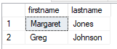

4)

SELECT [firstname], [lastname], [balance]

FROM [dbo].[client]

WHERE [balance] BETWEEN 50 AND 150;

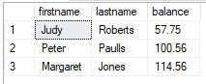

5)

SELECT [firstname], [lastname], [city]

FROM [dbo].[client]

WHERE [firstname] = 'Mary'

AND [lastname] = 'Nelson';



6)

SELECT [firstname], [lastname], [balance], [city]

FROM [dbo].[client]

WHERE [balance] < 200

AND [city] = 'Dunedin';

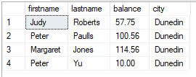

7)

SELECT [custref], [creditlimit], [balance], [creditlimit]-[balance] as 'NewBalance'

FROM [dbo].[client];

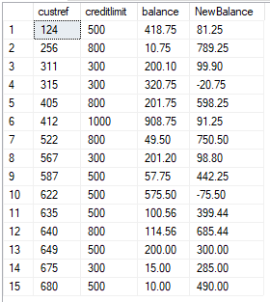

8)

SELECT [orderref], [partref], [quantity], [quotedPrice], [quantity]\*[quotedPrice] as 'LineTotal'

FROM [dbo].[orderline];

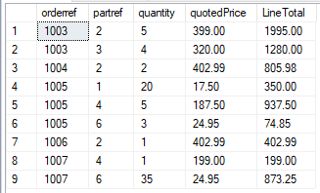

9)

SELECT [orderref], [orderdate]

FROM [dbo].[custorder]

WHERE [orderdate] > '1999-6-1';

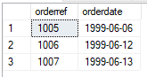

10)

SELECT [city], COUNT(\*) as 'Number in each city'

FROM [dbo].[client]

GROUP BY [city]

HAVING COUNT(\*) > 3;

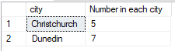

11)

SELECT [dbo].[rep].[repref], SUM([balance]) as 'Total balance'

FROM[dbo].[rep]

INNER JOIN [dbo].[client] ON [dbo].[rep].[repref] = [dbo].[client].[repref]

GROUP BY [dbo].[rep].[repref];

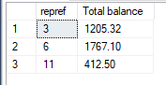

12)

SELECT [city], MAX([balance]) as 'Maximum balance'

FROM [dbo].[client]

GROUP BY [city];

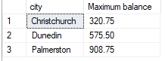

13)

SELECT CONCAT([firstname], ' ', [lastname]) as 'Client name', CONCAT([RepFirstname], ' ', [RepLastName]) as 'Rep Name'

FROM[dbo].[rep]

INNER JOIN [dbo].[client] ON [dbo].[rep].[repref] = [dbo].[client].[repref];

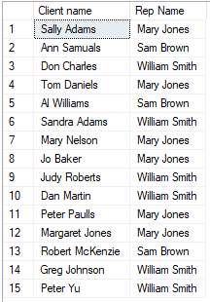

14)

SELECT [orderref], [firstname], [lastname], [orderdate]

FROM [dbo].[client]

INNER JOIN [dbo].[custorder] ON [dbo].[client].[custref] = [dbo].[custorder].[custref];

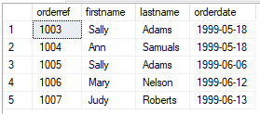

15)

SELECT [orderref], [description], [onHand]

FROM [dbo].[orderline]

INNER JOIN [dbo].[part] ON [dbo].[orderline].[partref] = [dbo].[part].[partref]

WHERE [orderref] = 1007;



16)

SELECT [orderref], [description], [quotedPrice], [quantity]

FROM [dbo].[orderline]

INNER JOIN [dbo].[part] ON [dbo].[orderline].[partref] = [dbo].[part].[partref]

ORDER BY [description];

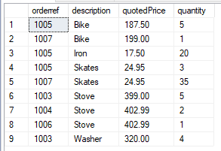

17)

SELECT [orderref], [description], [quotedPrice], [quantity]

FROM [dbo].[orderline]

INNER JOIN [dbo].[part] ON [dbo].[orderline].[partref] = [dbo].[part].[partref]

WHERE [quotedPrice] > 200;

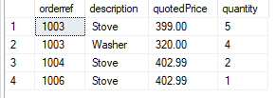

18)

SELECT [dbo].[custorder].[orderref], [orderdate], [firstname], [lastname], [description], [unitPrice]

FROM [dbo].[client]

INNER JOIN [dbo].[custorder] ON [dbo].[client].[custref] = [dbo].[custorder].[custref]

INNER JOIN [dbo].[orderline] ON [dbo].[custorder].[orderref] = [dbo].[orderline].[orderref]

INNER JOIN [dbo].[part] ON [dbo].[orderline].[partref] = [dbo].[part].[partref];

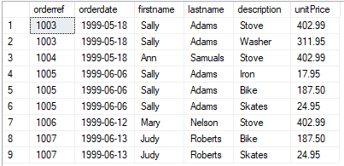

19)

SELECT [dbo].[custorder].[orderref], [orderdate], [firstname], [lastname], [description], [unitPrice]

FROM [dbo].[client]

INNER JOIN [dbo].[custorder] ON [dbo].[client].[custref] = [dbo].[custorder].[custref]

INNER JOIN [dbo].[orderline] ON [dbo].[custorder].[orderref] = [dbo].[orderline].[orderref]

INNER JOIN [dbo].[part] ON [dbo].[orderline].[partref] = [dbo].[part].[partref]

WHERE [orderdate] > '1999-6-10';

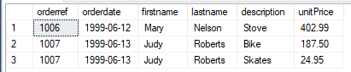

20)

SELECT [dbo].[custorder].[orderref], [orderdate], [firstname], [lastname], [RepFirstname], [RepLastName], [description]

FROM [dbo].[client]

INNER JOIN [dbo].[custorder] ON [dbo].[client].[custref] = [dbo].[custorder].[custref]

INNER JOIN [dbo].[orderline] ON [dbo].[custorder].[orderref] = [dbo].[orderline].[orderref]

INNER JOIN [dbo].[part] ON [dbo].[orderline].[partref] = [dbo].[part].[partref]

INNER JOIN [dbo].[rep] ON [dbo].[client].[repref] = [dbo].[rep].[repref];

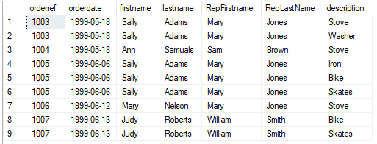

21)

SELECT CONCAT([RepFirstname], ' ', [RepLastName]) as 'Rep Name', SUM([balance]) as 'Total Balance'

FROM [dbo].[client]

INNER JOIN [dbo].[rep] ON [dbo].[client].[repref] = [dbo].[rep].[repref]

GROUP BY CONCAT([RepFirstname], ' ', [RepLastName])

ORDER BY SUM([balance]);

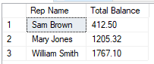

22)

SELECT [orderref], SUM([quantity]\*[quotedPrice]) as 'Total Linetotal'

FROM [dbo].[orderline]

GROUP BY [orderref];

